
Early Years Evening DROP-IN SESSION for Childminders with Denise Filer an Early year’s Emotional Wellbeing and Behaviour Specialist in Spring and Summer 2026 :
Thursday 26th March 2026 5.00pm – 8.00pm
Book time with Denise Filer: 26th March 2026 Childminder evening drop in • This link will expire on: May 24, 2026

Thursday 16th April 2026 5.00pm-8.00 pm
Book time with Dominique Johnson: Childminder Drop in session

Thursday 7th May 2026 5.00pm-8.00pm
Book time with Anna Mutch: 07/05/26 Childminder drop in - Copy

Thursday 11TH June 2026 5.00pm-8.00pm Book time with Julie Mcelhinney: Child Minder Evening Drop-In Thursday 11th June 2026
If you would like advice around Early Years Emotional Wellbeing and Behaviour, use the booking links provided under each date. Please note, if no time slots are showing once you have clicked on the desired date this means that the session is fully booked.
The aim of this session is to provide a solution focus approach for your Early Years Cohort with regards to Emotional Wellbeing and Behaviour.
Any questions, please email; denise.filer@hertfordshire.gov.uk

information:
Booking information:

1. please open the hyperlink next to the desired date on the flyer. You should then come to my bookings page
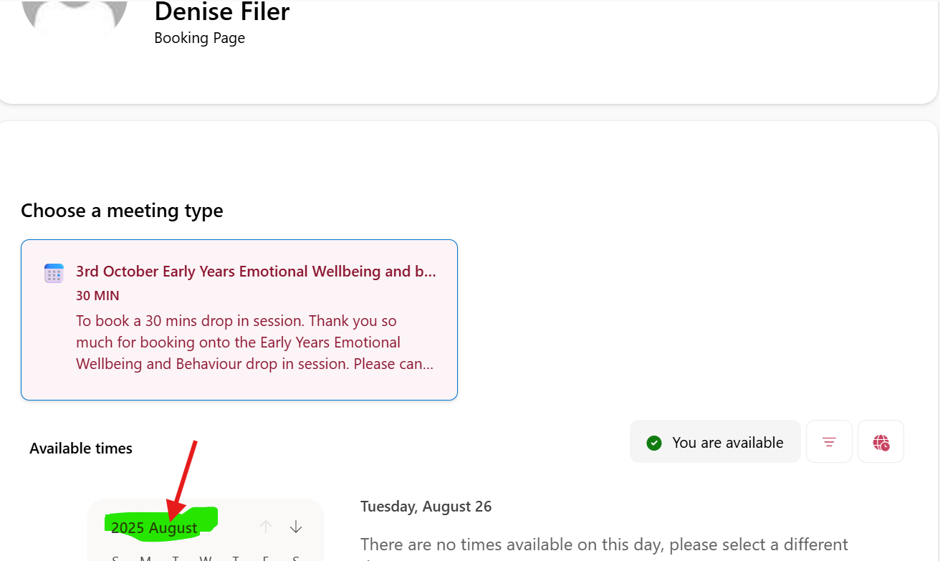2.You Will need to use the Callander to click on the desired date.
3.Once the date has been selected you should then see what availability there is for that date.
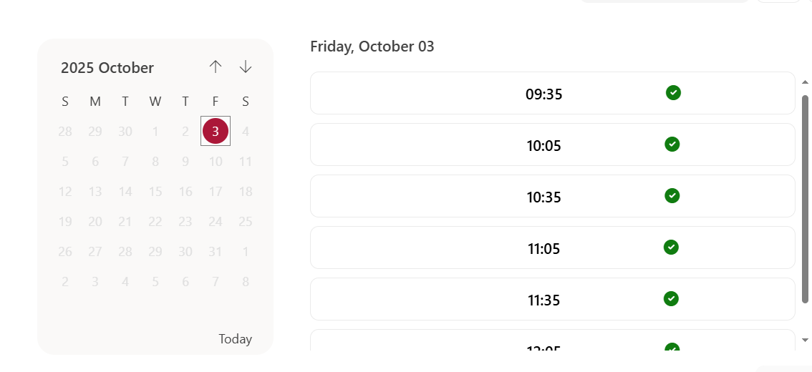

4. book a slot that works for you.

Summer term
Early Years Therapeutic Approaches to Behaviour (TAB) Evening training for Childminder
• Session 1 - 14 May 2026 7pm-9pm
• Session 2 - 21 May 2026 7pm-9pm

Booking link Childminder Early Years Therapeutic Approaches to Behaviour (TAB) 2 VIRTUAL session to complete | Hertfordshire County Council
About this event
Childminder evening virtual training. Please note both sessions need to be attended to complete this full TAB training.
TAB is the local authority’s preferred strategy to supporting emotional wellbeing and behaviour for children in the Early Years (0-5years).
The approach forms part of the authority’s Emotional Wellbeing and Behaviour Strategy and is underpinned by therapeutic approaches to behaviour management.
Venue
Online live streamed - Microsoft Teams
Only one booking is needed for both sessions as it is a requirement that both sessions are completed.
Pre-course learning. TAB builds upon the information from Attachment Aware and Trauma Informed. Toolkit from Hertfordshire Virtual School. Please access the below recorded training before attending TAB sessions
Understanding Attachment Aware & Trauma informed practice - part 1
Understanding Attachment Aware and Trauma Informed Practice - Part 2

