Children & Young People’s Therapies referral forms are now Online!

What is changing?
Starting on the 4th March, HCT will launch the updated digital referral forms. These changes have been made to help improve patient experience by providing easier access to services and streamlining the overall process.

CYPT services includes Childrens Occupational Therapy, Physiotherapy & Speech, and Language Therapy. The digital referral form route is accessible by an online link for use by appropriate referrers including Schools, Parents/Carers, Self-referrals, GP’s and Health Care Professionals.

You can make a referral to these services by following the below links or visiting our website www.hct.nhs.uk
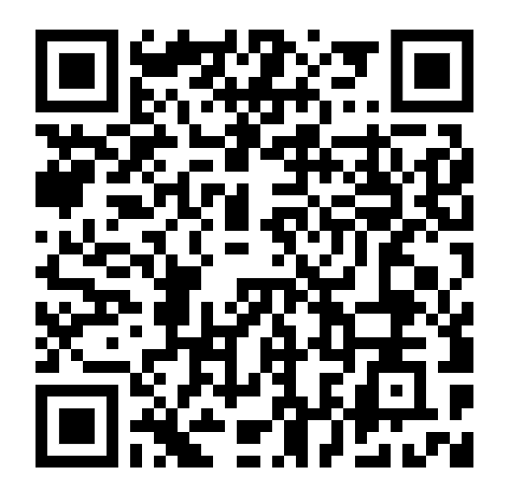

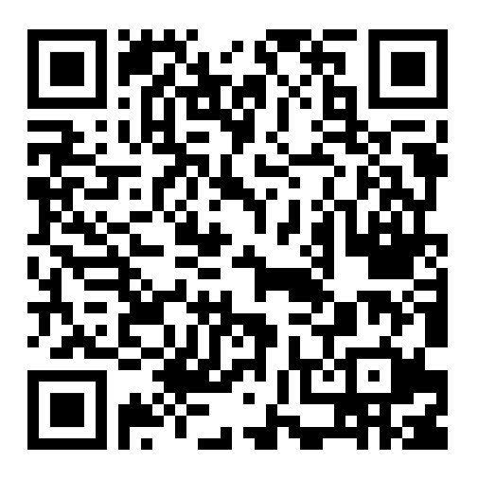
Speech & Language
Referral Form
Occupational Therapy
Referral Form
Physiotherapy
Referral Form






