2023/24




Hertfordshire Early Years SENCo

Resource Pack

Early Years SEND Team

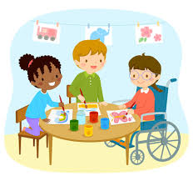



SENCo Resource Pack

This set of documents collates the formats that you would have used or been signposted to throughout your SENCo training.

The pack has been put in an order to reflect the Graduated Approach, to ensure accessibility and to highlight the Hertfordshire process.


Hertfordshire SEND Support Triangle
For Some
For Few
For All
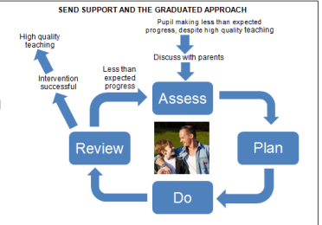
HIGH QUALITY TEACHING
- Partnership Working with Parents/Carers
- Differentiation by age and stage
- Planning
- Observations
- Learning Journal
- Partnership working with parents and carers
- Focused observations
- Assessments (Developmental journal, IAELD etc.)
- Targeted planning and differentiation
- IEP or equivalent
RAISED CONCERNS
ADVICE FROM OUTSIDE AGENCIES
Ongoing support from outside agencies.
EHCP & HNF

Pre-graduated Approach

Please remember as part of high-quality teaching you will need to differentiate activities and the way you teach; you will also be making reasonable adjustments to your environment.
Differentiation means adjusting or changing provision/activities and the expected outcome based on the specific needs of the child. In early years’ environment, differentiation is subtle and takes some practice to do well, but once you get in the habit, it’s second nature.


FOCUSED OBSERVATION
Name |  |  | Date of Birth
Date/Time | Name of practitioner
Focus of observation

Child initiated activity |  |  | Adult led activity
Solitary Play? |  | Small Group Play? |  | Large Group Play?
Context (which area are they in? Who with? Etc)

Evidence - How were these skills demonstrated? What is happening? What is the child saying or doing?

Summary/Hypothesis/Reflections

Next steps


FOCUSED OBSERVATIONS
Who do I respond well to?
What are my strengths?
What strategies have I developed for myself?
How do I communicate?
What motivates me?
If I have a medical condition, is that affecting my learning?
What skills do I need to develop?
How well do I interact with adults and children?
How well do I cope with transitions and changes in routines?
What skills do I need to develop?
How well do I play?
How am I coping with my physical skills?
What support do I need?
Name:
DOB:
Date of Observation:
FOCUSED OBSERVATION
STRENGTHS | AREAS TO DEVELOP

Initial Consultation Meeting with Parents/Carers

Setting Childs Name:
Date: Parent/Carers Name:
Time and place of meeting:
Planned length of meeting:
Adults/agencies involved in meeting:

Reason for meeting:

People present:

Information Discussed:
Child strengths/interests, needs? How would the parents/carers like to be involved?

Next Steps:

Any confidentiality issues:

Signatures Parents/Carers Setting:

Who is going to be present at meeting? Would parents/carers like anyone else to attend meeting to support them a family member, friend, health visitor? Do they need support such as person to translate if their first language is not English?

SEN Support

SEND support focuses on giving children with special educational needs help that is additional or different from support generally given to other children of the same age. SEND support is put in place to help children achieve the outcomes or learning objectives set for them.

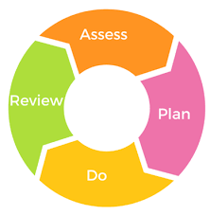

SEN Support Monitoring Sheet

Name | DoB | Parental consent? | Broad Area of Need/presenting need | IAELD / EYDJ Y/N  (Assess)  Review date | SEN Support Plan/ IEP (Plan) | SEN Support Tracking Sheet/ observations (Do) | SEN Support Plan/ IEP Review Date (Review) | Funding  EYIF  DAF  LHNF | EHCP  HNF | Professionals involved | Comments

Person Centred Tools

Person centred planning is designed to be holistic, outcome-focused, and aspirational. Person centred planning is a way of supporting a child to achieve the things that are important to them in their life.

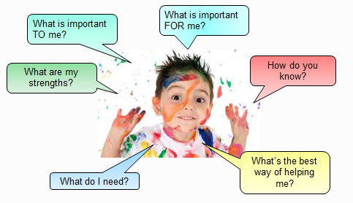

Good day/ Bad day

  Good day |   Bad day
What will it take to have more good days and less bad days?

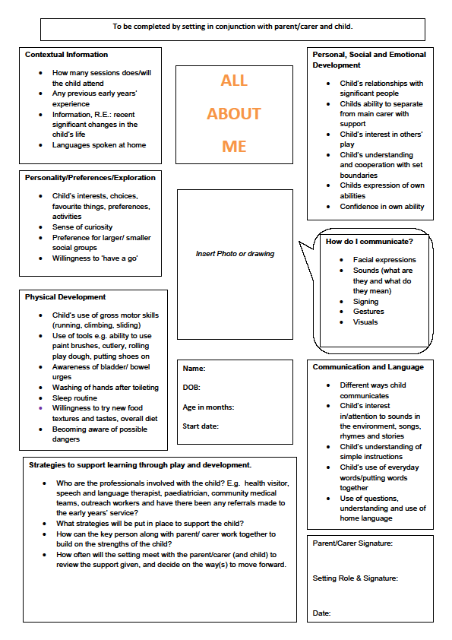
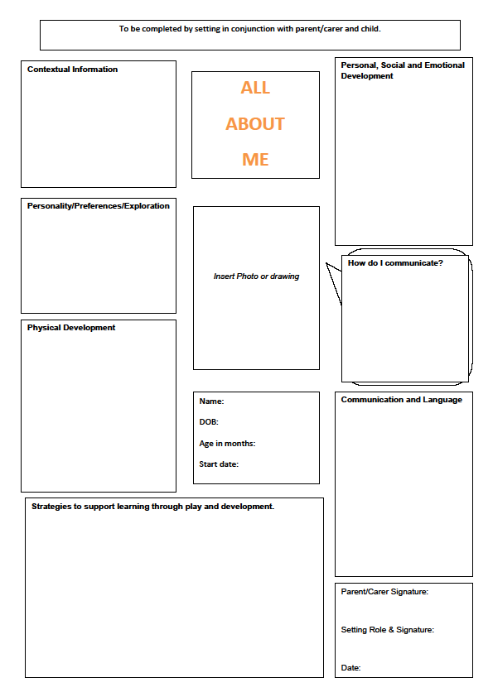

One page profile
I would like you to know that I enjoy:
Photo
Things I need help with:
You can make learning easier for me by:

Things my family would like you to know about me

The thing my family would like for me is:
To be able to
Things my Key Person would like you to know about me:

The thing my helpers would like for me is:
To be able to
Plan no:
Date:

Assessments

- Individual Assessment of Early Learning and Development (IAELD), for the identification of additional needs for children in the early years.
https://thegrid.org.uk/assets/iaeld-interactive-mar2020.pdf

- Early Support Developmental Journal (EYDJ), document to track progress and identification of additional needs for children in the early years. Untitled (councilfordisabledchildren.org.uk)


Area of Development | Developing (developing/seen sometimes) skill statements and Step No. |  |  |  |  | N/A
Personal, social and emotional

Communication

Physical

Thinking

Early Support Early Years Developmental Journal Summary of ‘developing’ skills

IAELD Summary of Emergent Skills- ‘sometimes seen’ skills
Area/Age | Sometimes seen |  |  |  |  | N/A
Play and early learning
Expressive language
Receptive language
Fine motor

Gross motor

PSE

Plan

Plans in your setting will be individual to children and unique to your setting. You can use plans which your setting has devised or the plans we offer in this resource pack. All plans must consider the information you have gathered from your assessment to formalise targeted support, these will be devised with the parents/carers.

When setting targets remember to be SMART:

Specific

Measurable

Achievable


Realistic

Time bound
- INDIVIDUAL EDUCATION PLAN PLAN NO: DATE:

NAME:  DOB: |  |  | SETTING:  NO SESSIONS CHILD ATTENDS & AM/PM/FULL DAY: |  |  | TERM/PERIOD:  REVIEW DATE:
EARLY YEARS EYIF DAF TNF LHNF EHCNA EHC PLAN HNF

ADULTS INVOLVED: |  |  |  |  | AGENCIES/ PROFESSIONALS INVOLVED:
CHILDS STRENGTHS: |  |  |  |  | AREAS TO DEVELOP:
LONG TERM OUTCOME | # | SHORT TERM OUTCOME |  | STRATEGIES AND ACTIVITIES (BOTH SETTING AND HOME) |  |  | REVIEW
 | 1 |  |  |  |  |  | DATE:
 | 2 |  |  |  |  |  | DATE:
 | 3 |  |  |  |  |  | DATE:
PARENTS/CHILD COMMENTS AND INVOLVEMENT, INCLUDING REVIEW OF THE OUTCOMES IMPLEMENTED AT HOME:

SIGNATURES SENCo: KP: PARENT/CARER:

- INDIVIDUAL EDUCATION PLAN (IEP) PLAN NO: 1 DATE: XX/XX/XXXX

NAME: XXXXXX  DOB: XX/XX/XXXX |  |  | SETTING: XXXXXXXXX  NO SESSIONS CHILD ATTENDS & AM/PM/FULL DAY:  3 X AM SESSIONS P/W |  |  | TERM/PERIOD: 6 WEEKS 1ST HALF SPRING TERM  REVIEW DATE: XX/XX/XXXX
IF: Inclusion Funding
DAF: Disability Access Fund
LHNF: Local High Needs Funding
HNF: High Needs Funding
EHCP: Education, Health and Care Plan
EARLY YEARS EYIF DAF TNF LHNF EHCNA EHC PLAN HNF

ADULTS INVOLVED:  PARENTS/CARERS NAMES/ CHILDMINDER /SENCO/ KP AND ANY OTHER ADULT SUPPORTING IMPLEMENTATION OF THE PLAN |  |  |  |  | AGENCIES/ PROFESSIONALS INVOLVED:  ADVISORY TEACHER (NAME) SaLT (NAME) OT (NAME)  INCLUSION WORKER (NAME) GP (NAME) HV (NAME)
CHILDS STRENGTHS:  USING YOUR FOCUSED OBSERVATIONS/ BASELINE/ PERSON CENTRED PLAN/ ASSESSMENT (IAELD/ EARLY YEARS DEVELOPMENTAL JOURNAL) |  |  |  |  | AREAS TO DEVELOP:  USING INFORMATION FROM YOUR FOCUSED OBSERVATIONS AND ASSESSMENT
LONG TERM OUTCOME | # | SHORT TERM OUTCOME  SMALL STEPS |  | STRATEGIES AND ACTIVITIES (BOTH SETTING AND HOME) |  |  | REVIEW
OVERALL OUTCOME AND WHAT WE WOULD LIKE TO SEE AS A RESULT OF OUR INTERVENTIONS (ASSESSMENT AND RESULTING OUTCOMES) | 1 | IS YOUR TARGET SMART?  SPECIFIC - DOES IT TELL US EXACTLY WHAT WE NEED TO DO? EQUIPMENT/ ADULTS ROLE  MEASURABLE- CAN YOU TELL EASILY IF THE CHILD HAS ACHIEVED THE OUTCOME?  ACHIEVABLE – HAVE YOU PICKED OUTCOMES THAT UTILISES THE CHILD’S ‘SOMETIMES SEEN’/ ‘EMERGING SKILLS’ (TAKEN FROM THE CHILD’S IAELD OR EYDJ)?  REALISTIC – DOES THE LONG TERM OUTCOME WORK TOWARDS SHORT TERM OUTCOMES WHICH HAVE BEEN IDENTIFIED?  TIME RELATED- HOW MANY TIMES EACH WEEK AND FOR HOW LONG? DATE BY WHICH THE OUTCOME WILL BE REVIEWED. |  |  |  |  | DATE:  - WHAT DID WE TRY?  Reflect on outcomes  - WHAT HAVE WE LEARNED? Improvements in an area of development  - WHAT ARE WE PLEASED ABOUT?  What worked well?  - WHAT ARE WE GOING TO FOCUS ON NEXT?  Continue outcomes but amend and reflect on them?  New outcomes based on assessment review and success of previous outcomes?  Refer to other professionals?  Return to high quality teaching?
 | 2
 | 3
PARENTS/CHILD COMMENTS AND INVOLVEMENT, INCLUDING REVIEW OF TARGETS IMPLEMENTED AT HOME:
THE PLAN SHOULD BE COMPLETED WITH THE PARENTS/CARERS OF THE CHILD AND THEIR VIEWS AND OPINIONS ADDED TO THE PLAN
OUTCOMES IMPLEMENTED AT HOME SHOULD BE INCLUDED IN THE SETTINGS REVIEW OF THE
REMEMBER THAT THIS IS A WORKING DOCUMENT WHICH CAN BE AMENDED/CHANGED AND REVIEWED AT ANY POINT
SIGNATURES SENCo: KP: PARENT/CARER:

Do

At this point you will be ensuring that observations are being gathered from the child’s SEN support plan.



Review

Please note that parents/carers are involved when you review your assessment and SEN support plan.

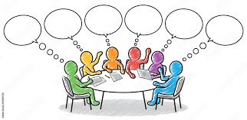



What have we tried?

What have we learned?

What are we pleased about?

What are we concerned about?

What do we need to do next?
Review for____________________
Date________________

SEND SUPPORT PLAN/IEP REVIEW
SEND SUPPORT PLAN /IEP NO: 1 DATE: XX/XX/XXXX

NAME:  DOB: | SETTING:  NO SESSIONS CHILD ATTENDS: |  | PERIOD: Number of weeks of plan  REVIEW DATE:
EARLY YEARS: EYIF DAF TNF LHNF EHCNA EHC PLAN HNF

ADULTS INVOLVED: PARENTS/CARERS NAMES/ CHILDMINDER /SENCO/ KP AND ANY OTHER ADULT SUPPORTING IMPLEMENTATION OF THE PLAN |  | AGENCIES INVOLVED:  ADVISORY TEACHER (NAME) SaLT (NAME) OT (NAME)  INCLUSION WORKER (NAME) GP (NAME) HV (NAME)
SHORT TERM OUTCOMES:
- WHAT DID WE TRY?
Reflect on each outcome (match to the original IEP)

- WHAT HAVE WE LEARNED? Improvements in an area of development

- WHAT ARE WE PLEASED ABOUT? What worked well?

- What did not work and why?

1.

2.

3.
ADDITIONAL COMMENTS:

NEXT STEPS:

WHAT ARE WE GOING TO FOCUS ON NEXT?
Before any review meeting – review any assessment originally used (IAELD/EYDJ)
- Continue outcomes but amend and reflect on them?
- New outcomes based on assessment review and success of previous outcomes?
- Refer to other professionals?
- Return to high quality teaching

PARENTS/CHILD COMMENTS AND INVOLVEMENT

SIGNATURES: PARENT/CARER: SETTING:

SEND SUPPORT PLAN/IEP REVIEW
SEND SUPPORT PLAN /IEP NO: DATE:

NAME:  DOB: | SETTING:  NO SESSIONS CHILD ATTENDS: |  | PERIOD:  REVIEW DATE:
EARLY YEARS: EYIF DAF TNF LHNF EHCNA EHC PLAN HNF

ADULTS INVOLVED: |  | AGENCIES INVOLVED:
SHORT TERM OUTCOMES:

1.

2.

3.

ADDITIONAL COMMENTS:

NEXT STEPS:

PARENTS/CHILD COMMENTS AND INVOLVEMENT

SIGNATURES : PARENT/CARER: SETTING:

INDIVIDUAL EDUCATION PLAN REVIEW/TRACKING PLAN

SEND Support Plan No: | Review Date: |  | Review No:
Setting:
Childs Name: |  | DOB:
No of sessions child attends: |  | No of actual sessions child attends:
Stage of Graduated Approach: |  | EYIF/ DAF/ LHNF |  | EHCP/HNF
Monitoring arrangements:

SEND Approach – Do
Who will be responsible for making sure that the SEND Action Plan is being implemented? Who will observe the child to keep track of progress and when? When and who will be involved in discussing the child’s progress?
Outcomes – what was successful/not successful:

SEND Approach - Review
Based on your monitoring arrangements. Did the child achieve the outcome? If yes what can the child now do? If no what could be the reason why – target set too high, child off sick, the child needs more time to work towards the outcome. Future plans – areas to revisit, refine and revise including ideas for future outcomes: Based on review, observations IAELD, does the child need to work further on the same developmental areas, work on a different developmental area? Work towards the next stage from the last outcome or set a different one?
Reports/information from people not present

Next steps:
Continue with SEN Support Plan Yes/No
Modify Sen Support Plan Yes/No
Continue SEN Support Graduated Approach Yes/No
Proceed to next stage Yes/No
Discontinue SEN Support Graduated Response Yes/No
Parents/staff/agencies involved in the review:

INDIVIDUAL EDUCATION PLAN REVIEW/TRACKING PLAN

SEND Support Plan No: | Review Date: |  | Review No:
Setting:
Childs Name: |  | DOB:
No of sessions child attends: |  | No of actual sessions child attends:
Stage of Graduated Approach: |  | EYIF/ DAF/ LHNF |  | EHCP/HNF
Monitoring arrangements:

SEND Approach – Do

Outcomes – what was successful/not successful:

SEND Approach - Review
Reports/information from people not present

Next steps:
Continue with SEN Support Plan Yes/No
Modify Sen Support Plan Yes/No
Continue SEN Support Graduated Approach Yes/No
Proceed to next stage Yes/No
Discontinue SEN Support Graduated Response Yes/No
Parents/staff/agencies involved in the review:

Tools to support a
‘Therapeutic Approach to Behaviour’

Therapeutic Approaches to Behaviour focuses on specific behaviours and challenges and how settings can approach the way children are supported.
TAB promotes analysing behaviour and what the behaviour is communicating. It looks closely at how experiences can negatively impact on behaviour, and the overall aim focuses on supporting a healthy understanding of inclusion in your setting.


This is the link to the Virtual School to access ‘Attachment and Trauma’ training, this training is a prerequisite to attending TAB training, as it is important that all settings are attachment and trauma aware.

https://www.hertfordshire.gov.uk/microsites/virtual-school/search-results/search-results.aspx?search_keywords=attachment%20and%20trauma%20toolkit
ABCCD Behaviour Tracking
Name | DOB | Age | Page #

A – Antecedent  Setting the context - What was happening BEFORE the incident? Location, people, noise level etc | B - Behaviour  What was the behaviour was observed? Was anybody harmed? What was said? Did you notice any significant body language? | C – Consequence  What happened after the incident? Other people’s reactions? Student’s reaction. | C –Communication  What might be the child trying to communicate? What needs might the child be trying to meet? | D – Do’s and Don’ts  Your action/response  Did it help? Did it hinder?  What would you do differently next time?
Date:  Time: |  |  |  | Adult’s name:
Date:  Time |  |  |  | Adult’s name:
Date:  Time |  |  |  | Adult’s name:

Anxiety Mapping

Anxiety | +5
Anxiety | +4
Anxiety | +3
Anxiety | +2
Anxiety | +1
 | 0
Dependency | -1
Dependency | -2
Dependency | -3
Dependency | -4
Dependency | -5

Anxiety Mapping Analysis and Evidence of Differentiation
 | Score | Staff/Location/Activity/Peer/Time  Predict it | Evidence of action  Prevent it
Raised Anxiety | +2  -  +5 | These items overwhelm the pupil | Planned Differentiation required to reduce anxiety
Raised Anxiety | +2 | These items run the risk of overwhelming the pupil | Monitoring needed
 | 0
Increased dependency | -2 | These areas run the risk of developing an over reliant | Monitoring needed
Increased dependency | -2  -  -5 | These areas have developed an over reliance | Differentiation needed to reduce this over reliance

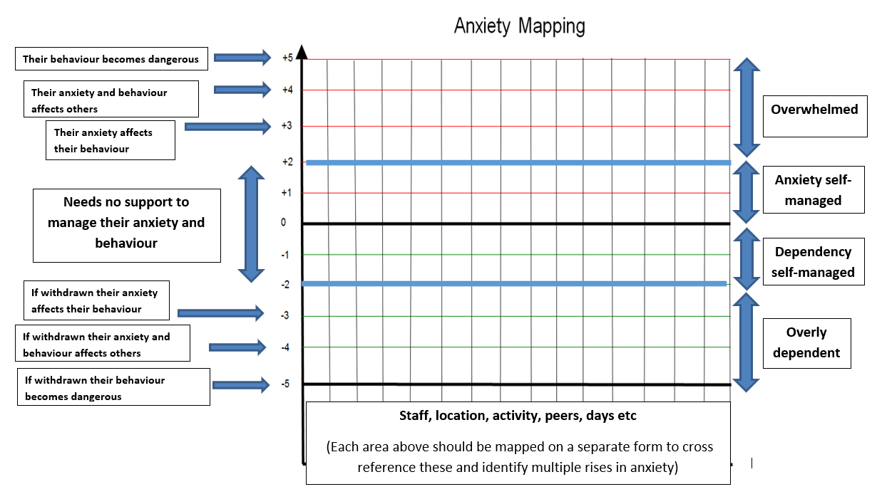
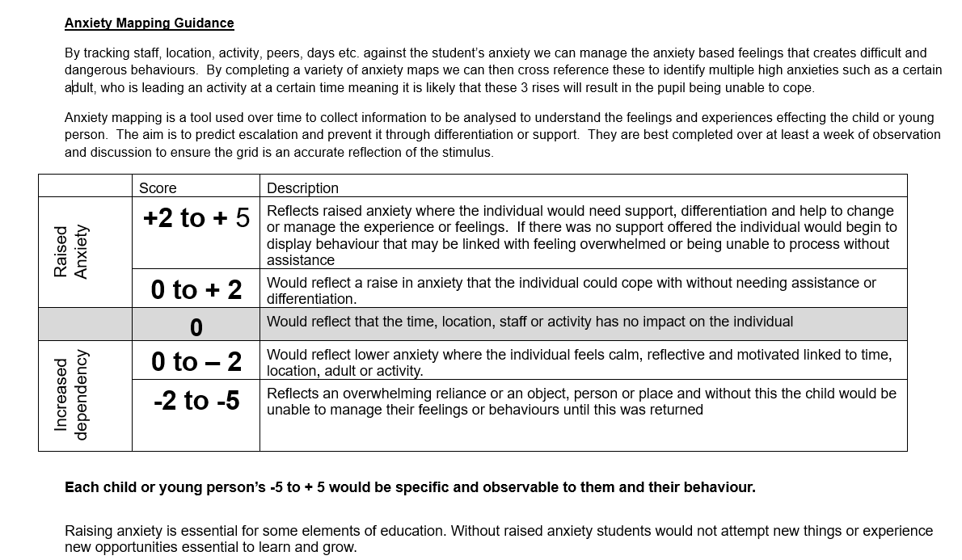
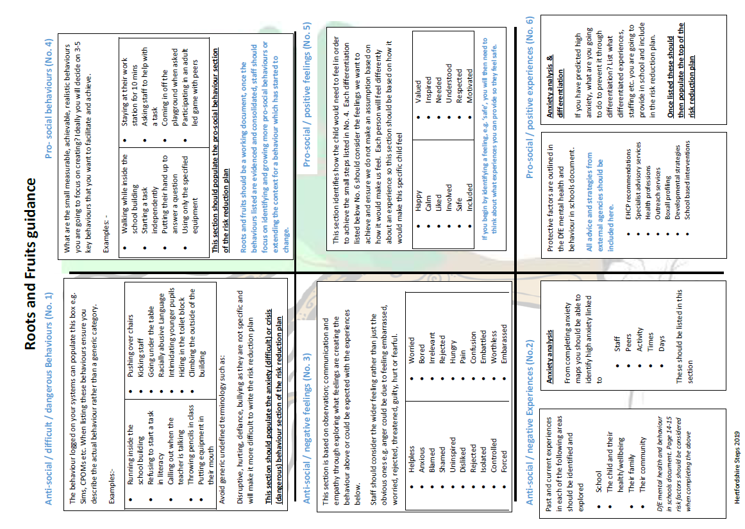

WELLBEING PLAN

NO: DATE:

NAME:  DOB: |  | SETTING:  NO SESSIONS CHILD ATTENDS: |  |  | PERIOD:  REVIEW DATE:
ADULTS INVOLVED: |  |  |  | RESOURCES/EQUIPMENT:
CHILDS STRENGTHS: |  |  |  | CONCERNS:
 | OUTCOMES & CRITERIA FOR SUCCESS |  | STRATEGIES TO BE USED (WHAT THE ADULTS WILL DO)
PARENTS/CHILD COMMENTS

SIGNATURES

PARENT/CARER: DATE:

Transition Tools

In your role you will need to consider the importance of transitions and the vital part you will have to play in this. As the SENCo you will be planning for children’s transitions, alongside parents/carers, the transitioning setting, professionals and most importantly ensuring that the child is at the centre.




Transition Level of Need Tool and Guidance

Some children may need particular help, including from other agencies, to ensure that their transition is as smooth as possible. Research suggests that transitions are central to young children’s development and emotional wellbeing. How the first transitions are handled can have a significant impact on a child’s capacity to cope with change in the short and long term and impact on the progress they make from their starting points.
The transition project aims to:

- build on current good practice and encourage consistency across Hertfordshire
- develop a pathway which will help schools receive pertinent information about a child’s level of need
- identify schools with cohorts that have high levels of need
- provide advisory and, where relevant, specialist support for schools that have cohorts with high levels of need
- provide professional development opportunities and contact with specialist professionals that can offer advice with cohort needs.

The project is designed to further improve the early identification and support for all children, particularly those with potential barriers to learning.

Link to the tool: Supporting smooth transitions | Herts for Learning

For further information please send your query to eytransition@hertsforlearning.co.uk
Please speak to your IDO if you would like a full copy.

Speech and Language Information and Tools

During your SENCo training we recognised tools and resources that you can access to support identification of speech, language and communication needs in children. As a result, you will then have information to help you to make interventions.





Hertfordshire Speech and Language Therapy Service

Please note that speech and language is not part of the Early Years SEND service.

Children's Speech and Language Therapy | Hertfordshire Community NHS Trust (hct.nhs.uk)

Contact the service
Telephone – 01923 470680 option 3, option 2
Email – hct.cyptherapies1@nhs.net
Twitter - twitter.com/Herts_CYPT
Advice Line – 01923 470680 option 3, option 1
This is a dedicated telephone number which parents, carers and professionals can call to speak to a therapist about a new referral or a child’s development. Please leave a message on our Advice Line and a therapist will contact you. Calls are responded to by a therapist on weekdays.
Virtual Screening Clinics – please see the ‘Making A Referral’ section below

Pre-School Children
Should you have concerns regarding your child’s speech and language development, please speak to your Health Visitor or local Family Centre in the first instance. They will often be able to provide you with advice on ways to support your child at home.
If you are still concerned after trying out their advice then please follow the guidance below.
Children under 2 years 6 months
Children under 2 years 6 months can be referred directly to the Children’s SLT service by a health professional if they have additional needs and there is a clearly identified language, communication, and/or eating/drinking need. See our referral guidelines for more information
Children aged 2 years 6 months and above (not in full time school)
If your child is aged over 2 years 6 months and you have ongoing concerns regarding their speech and language skills, then please refer to one of our screening clinics. These clinics offer an opportunity for you to talk with the therapist regarding your child’s development and for us to gather information to understand your child’s needs.
The criteria for attending a screening clinic is as follows:
- Screening clinics are for preschool children from aged 2 years 6 months and above, who are not yet in full time school
- We are unable to see children with Education, Health and Care plans, or those requiring associated assessment within these clinics. A referral should be made by your child’s Special Education Needs officer in this instance
- Children already known to the service, or children outside of the given age range for the screening clinics are not able to be seen
- We are unable to complete assessments of eating and drinking at screening clinics
If you have contacted our Advice Line and continue to require access to support and advice from the Speech and Language Therapy Team, please follow these steps:
- Complete the online referral form
If you have any difficulty completing the form and sending the information, please contact our administration team on 01923 470680 option 3 option 1.
Eating and drinking difficulties
If you are worried about your child’s eating and drinking skills, please speak to your child’s health visitor or GP in the first instance. Referrals for eating and drinking difficulties will only be accepted from a health professional, for example GP, health visitor, paediatrician, dietician etc. We would not carry out assessments of eating and drinking at our screening clinics.


WellComm


WellComm - GL Assessment (gl-assessment.co.uk)

- The complete speech and language toolkit from screening to intervention

- Devised by SLTs as a screening tool and intervention programme

- A complete speech and language toolkit available to early years practitioners working with children from 6 months to 6 years

- Can be used in any early years setting

- Not a standardised assessment and not intended to be a diagnostic tool but ‘a profile of strengths and needs’

- Gives practitioners an awareness of appropriate language development at each stage and gives suggestions for activities

ECAT: Every Child a Talker Tool
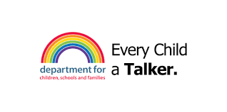

The child monitoring tool enables practitioners to assess the developmental level of children’s speech, language and communication. It is structured across 4 strands which, although appear separate, are interlinked.

It is proposed that observations link to the best fit for a child in each strand (see information on the reverse of the tool). The information is to be put onto the overview sheet along with the child’s chronological age in months. The developmental stage needs to be compared to the child’s chronological age to establish if the child is ‘at risk of delay’, ‘as expected’ or ‘ahead’

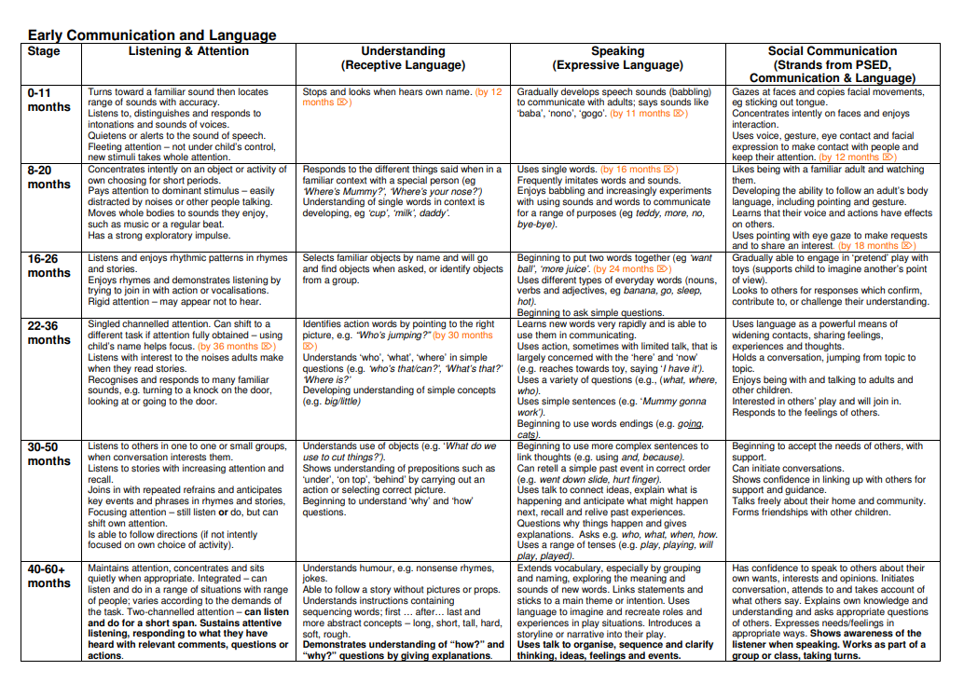
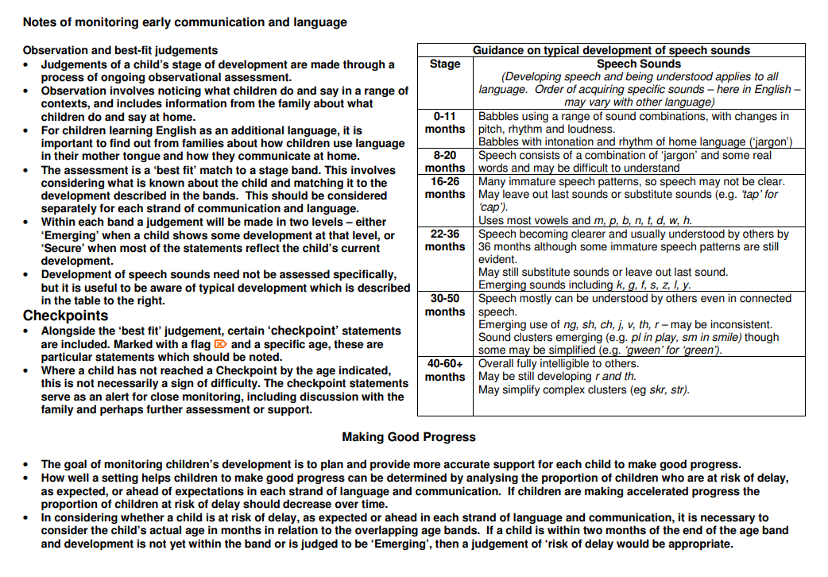

Referral Documents

Single Service Request form and ISL Baseline form:

ISL service request - Hertfordshire Grid for Learning (thegrid.org.uk)

Please remember (if not making a condensed referral) you will need to include:

- Via Herts FX send TWO cycles of assess, plan, do and review

- IAELD or EYDJ summary sheet with the baseline and review completed

- 2 IEPs (cycle 1 and cycle 2)

- Evidence of observations for cycle 1 and cycle 2

- Formalised review of cycle 1 and cycle 2

- Any professional reports and/or other relevant information

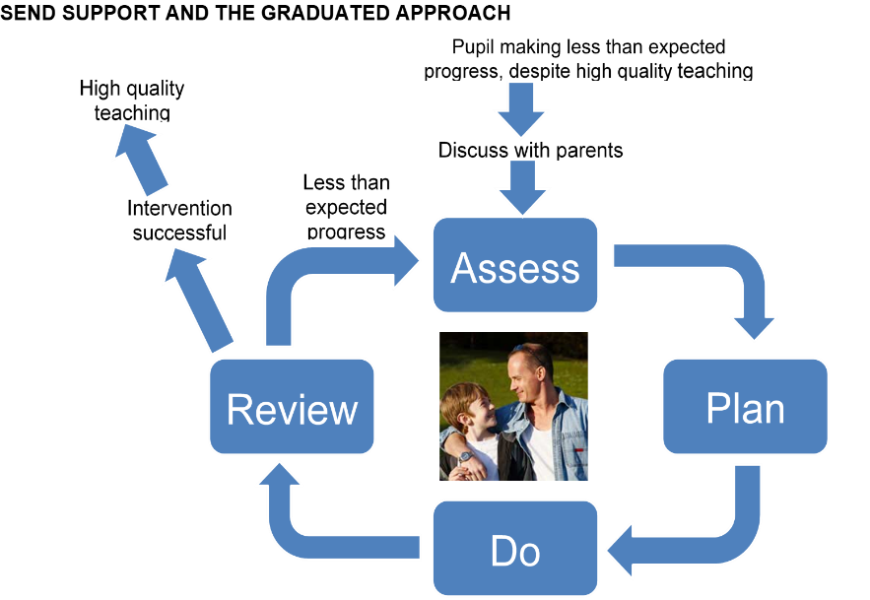

Early Years Funding Streams

Early Years Inclusion Funding
Early years inclusion funding is there to help providers deliver extra support to children who are displaying emerging additional needs. The extra funding could be used by providers to pay for things such as additional equipment or staff training to support the child.
Early years inclusion funding (hertfordshire.gov.uk)

Disability Access Fund
This is extra funding for early years providers to help support children with identified special educational needs or disabilities. It helps your child to access free early education places by supporting providers to make reasonable adjustments to their settings.
Disability access fund (DAF) (hertfordshire.gov.uk)

Local High Needs Funding
The Local High Needs Funding system is to support children and young people (CYP) with emerging high needs or for CYP who have needs that fall outside the EHCP process.

High Needs Funding
HNF is additional funding provided to support inclusion and meet the needs of children and young people with significant needs in mainstream schools and settings. As HNF is for children and young people with significant needs, the needs outlined in the EHCPs are used to determine the level of top-up funding.

Top-up High Needs Funding (HNF) in mainstream schools - Hertfordshire Grid for Learning (thegrid.org.uk)



Education, Health and Care Plans

An education, health and care plan (EHCP) is a legally binding document that:
- describes all of the special education, health and care needs of the child or young person which relate to their disability
- sets out all of the extra help and support they will need to overcome barriers to learning
- identifies meaningful education and other outcomes they would like to achieve as they prepare for adult life.

Education, health and care plan (EHC) - Hertfordshire Grid for Learning (thegrid.org.uk)



Additional Documents and Websites

The following pages consist of links to information, training, and resources which you may find useful in your role as the SENCo.

- Hertfordshire Local Offer
- Families First
- My Baby’s Brain training
- Health Care Plan
- Assess, Plan, Do and Review Recording Sheet
- Links to useful resources




Hertfordshire Local Offer
The Hertfordshire Local Offer

The Local Offer lets parents and young people know what special educational needs and disabilities services are available in Hertfordshire, and who can access them.

Areas covered are:

- Support with education
- Courses and activities in Hertfordshire
- Services for children and young people (ages 0-25)
- Services for parents, carers and families
- Money
- Education, Health and Care Plans (EHCP)
- Early Years (0-5)
- Preparing for adulthood
- National and local SEND policies
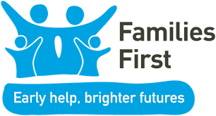
- Contacting a SEND service

Families First
Families First (hertfordshire.gov.uk)

Families First is the term used in Hertfordshire for services that work together to support families who need extra help. These are also known as early help services.
We all experience difficulties at some point. Families First can help you find early help and information to prevent issues from getting worse.
If you need more help than your usual support network - for example your health visitor, school, doctor or family centre - we can work with you and your family to create a package of support.

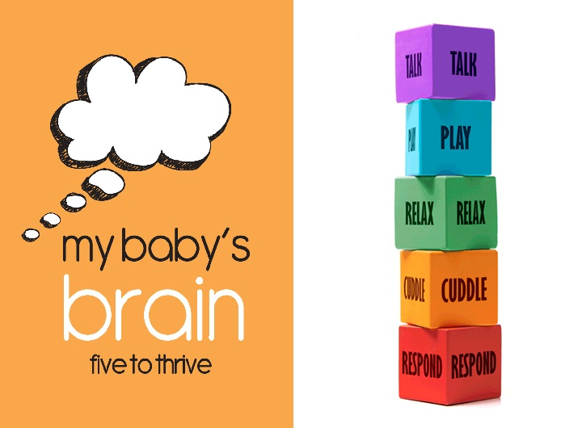
My Baby Brain Training

https://www.hertfordshire.gov.uk/services/schools-and-education/childcare-and-advice-for-parents/parents-and-family-support/my-babys-brain/my-babys-brain-helpful-resources.aspx#DynamicJumpMenuManager_1_Anchor_1

Five to Thrive

Your child's body grows better when you give the child good food. Your child's brain grows better when you do five simple things that feed the growing brain:

Respond • Cuddle • Relax • Play • Talk

These are your child's daily ‘five to thrive’ – the building blocks for a healthy brain. A healthy brain will help your child be happy in themselves, make friends and enjoy their family, as well as being the best start for learning once they go to school. And every day will bring many opportunities to give your baby’s brain what it needs to grow well.

Courses for professionals
Herts Early Help Commissioning team have worked with our My Baby’s Brain partner, KCA, to refresh the current training with a new programme. We are still delivering the key messages of Five to Thrive and Vulnerability, Trauma and Recovery, but also incorporating a great depth of learning for professionals and a continuous focus on resilience and managing toxic stress.

Template A: individual healthcare plan

Name of setting
Child’s name
Room/Group
Date of birth
Child’s address
Medical diagnosis or condition
Date
Review date
Family Contact Information
Name
Phone no. (work)
(home)
(mobile)
Name
Relationship to child
Phone no. (work)
(home)
(mobile)
Clinic/Hospital Contact
Name
Phone no.
G.P.
Name
Phone no.

Who is responsible for providing support in the setting

Describe medical needs and give details of child’s symptoms, triggers, signs, treatments, facilities, equipment or devices, environmental issues etc

Name of medication, dose, method of administration, when to be taken, side effects, contra-indications, administered by/self-administered with/without supervision

Daily care requirements

Specific support for the child’s educational, social and emotional needs

Arrangements for visits/trips/outings etc

Other information

Describe what constitutes an emergency, and the action to take if this occurs

Who is responsible in an emergency (state if different for off-site activities)

Plan developed with

Staff training needed/undertaken – who, what, when

Form copied to

Template B: parental agreement for setting to administer medicine
The school/setting will not give your child medicine unless you complete and sign this form, and the school or setting has a policy that the staff can administer medicine.

Date for review to be initiated by
Name of school/setting
Name of child
Date of birth
Group/class/form
Medical condition or illness
Medicine
Name/type of medicine
(as described on the container)
Expiry date
Dosage and method
Timing
Special precautions/other instructions
Are there any side effects that the school/setting needs to know about?
Self-administration – y/n
Procedures to take in an emergency
NB: Medicines must be in the original container as dispensed by the pharmacy

Contact Details
Name
Daytime telephone no.
Relationship to child
Address
I understand that I must deliver the medicine personally to | [agreed member of staff]

The above information is, to the best of my knowledge, accurate at the time of writing and I give consent to school/setting staff administering medicine in accordance with the school/setting policy. I will inform the school/setting immediately, in writing, if there is any change in dosage or frequency of the medication or if the medicine is stopped.

Signature(s) Date

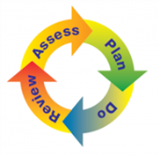
Assess Plan Do Review recording sheet

Childs name…………………….………. DOB…………………..Sessions attending …….………………..

Assess: What are the child’s needs/barriers to learning? What is their level of attainment and progress? What are the views of parents, KP, other practitioners and child? IAELD/Early Support Journal information?

Plan: What can we put in place to support this chid? Do we need to make any referrals or seek advice (IDO, if child is not on any ones caseload)? What outcome do we want to achieve for the child?

Do |  | Review
Actions Taken | Date | Outcome | Date

SENCo Development Plan
Outcome/objective | Tasks  (What you need to do to achieve your outcome/objective) | Success criteria  (How you can identify your success) | Time frame  (When you need to achieve your outcome/objective by) | Resources  (The resources you will need for each task)
EXAMPLE TO SUPPORT SENCO:  Research the Four Broad Areas of Need in the SEND Code of Practice | - Allocate SENCo time to update knowledge | - Being able to identify a child’s main presenting need within one of the Four Broad Areas of Need | - Date of completion (ensuring a realistic timeframe) | - SEND Code of Practice  - Allocated SENCo time
EXAMPLE TO SUPPORT COLLEAGUES:  Book colleagues on Key Person training | - Contact IDO, ask when the next training is available.  - Submit name and email addresses of candidates to IDO | - Key Person has completed their training  - KP fed back their training in the staff meeting  - Using the information from the training to initiate the Graduated Approach with support from the SENCo | - Date of training being delivered  - Date of team meeting when shared | - Staff cover for the date of the Key Person training

Links to useful resources

- Department of Education guidance for the Early Years SENCo
The role of the early years SENCO (publishing.service.gov.uk)

- NASEN Early Years SEND Resources
Early Years | Nasen

- Special Educational Needs and Disability Code of Practice 2015 - https://www.gov.uk/government/publications/send-code-of-practice-0-to-25

- Disabled children and the Equality Act 2010 for Early years.
Disabled Children and the Equality Act 2010 for Early Years (councilfordisabledchildren.org.uk)

- Hertfordshire Behaviour Strategy
http://www.thegrid.org.uk/learning/behaviour/policies/policies.shtml

- Early Support Developmental Journal
Early Years Developmental Journal (councilfordisabledchildren.org.uk)

- Individual Assessment of Early Learning and Development (IAELD)
iaeld-interactive-mar2020 (thegrid.org.uk)
- Inclusion Development Programme/National Strategies
- Supporting Children with Speech, Language & Communication Needs
Inclusion_Development_Programme_Speech_Language+Communication.pdf (foundationyears.org.uk)
- Supporting Children on the Autism Spectrum
Inclusion Development Programme Supporting children on the autism spectrum: Guidance for practitioners in the Early Years Foundation Stage (foundationyears.org.uk)

- Managing Medicines in Schools and Early Years Settings (updated Aug 2017)
https://www.gov.uk/government/publications/supporting-pupils-at-school-with-medical-conditions--3

- Health protection in schools and other childcare facilities.
https://www.gov.uk/government/publications/health-protection-in-schools-and-other-childcare-facilities

- Reasonable adjustments for disabled children.
https://www.equalityhumanrights.com/en/publication-download/reasonable-adjustments-disabled-pupils

- Speech and Language
Speech and Language UK – Speech and Language UK: Information and support

- Supporting Children Learning English as an Additional Language
National Strategies. (ARCHIVED)
http://webarchive.nationalarchives.gov.uk/20110202093118/http://nationalstrategies.standards.dcsf.gov.uk/node/84861

- Autism
http://www.autismeducationtrust.org.uk/
http://www.autism.org.uk/

- GOV campaign recommended by the foundation years
start4life– Simple fun, activities for kids aged 0 – 5 (campaign.gov.uk)

- Continence Guidance for Early Years Settings/Supporting Children who are in Nappies
coping-with-incontinence (thegrid.org.uk)
https://www.eric.org.uk/

- Early Support Materials
Council for Disabled Children

- Family Centres
Hertfordshire Family Centre Service - Hertfordshire Grid for Learning (thegrid.org.uk)

- What to expect in the Early Years Foundation Stage: a guide for parents
What-to-expect-in-the-EYFS-complete-FINAL-16.09-compressed.pdf (foundationyears.org.uk)
4Children_ParentsGuide_2015_WEB.pdf (foundationyears.org.uk) – old version

