


Early Years SEND Service

'This is my world'

My name is:

Insert a photograph of the child here, ensuring consent has been gained.

This booklet will help you to know more about me and help us to get along well together.

Date:
Completed by:
Role:


 My current information:
I like to be called (preferred name/shortened):
My date of birth is:
My parents/carers names are:
The setting I currently attend is:
My key person at this nursery is:
I attend (note days and time):
If you need to contact my previous nursery, please speak to:

Setting telephone number is:
Setting email address is:

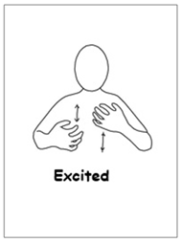 When I am excited or overstimulated, I:

E.g.
- When I am excited, I like to jump around.
- I will also tell you that I am excited, using certain words and phrases (this may be from TV/music).
- I like to dance and sing when I am excited.
- uses stimming to regulate or show excitement (describe the movement)

 When I am sad, anxious, or overwhelmed, I:

E.g.
- Sometimes I like to take myself away and be alone.
- Sometimes I like music/books to calm me down.
- I like an adult to support me when I am sad, the adult will need to...
- use stimming to regulate, describe the movement

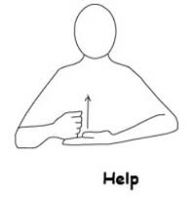 You can help me by:

E.g.
- Giving me some time and take me to the sensory room.
- Sometimes it helps to distract me with a favourite toy/having some planned activities.
- Sometimes I need to be left where I am to calm down.
- Providing a sensory break when you can start to see me beginning to struggle, early signs of this are...

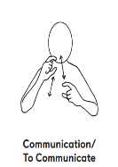 You can help me communicate and understand by:

E.g.
-Talking to me in clear simple language.
- Using objects of reference.
-Signing (Makaton/BSL/gestures).
-Repeating back phrases to clarify and providing time for me to process information.
-Using visuals (timelines, routine boards, ‘now and next’, choosing boards).
-Using social stories (if appropriate for age and stage of development).
-Using timers and countdowns.

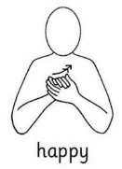 I enjoy and am happy when:

E.g.
-Spending time with adults
-When I am in a safe and familiar routine
- Messy play
- Music
-Cooking
-Drawing
-Books, stories, songs and rhyme
-Cars, trains, boats, planes (transport)
-Food and snacks
-Outdoor play, running, Hide and Seek...
-Pretend play e.g., cooking, washing baby

 I don’t enjoy:
E.g.
-Being in noisy rooms/spaces.
-Lots of children/people.
-Transitions.
-Having to sit for long periods of time.
-Having to finish something when I’m not ready.
-Touching play items which are wet/cold/sticky/dirty

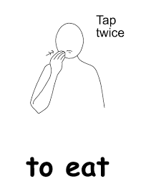 At snack time, I:
E.g.
-Like to have choices shown to me on a choice/choosing board/ visuals/objects of reference.
-Like to have a song or rhyme to help me to transition.
-Like to tell you when ‘snack time has finished’ or I find it helpful if the adult can tell me when snack time has finished.
-Like the same cup/plate/seat.
-I may struggle with foods and textures that I am not familiar with

I need help to:
E.g.
-Open my lunch box and packets.
-Drink from an open cup.
-Use a knife/fork/spoon.
-I am left-handed/right-handed, sometimes I find manipulating tools tricky.
-I need support to get dressed and undressed and to put my shoes on and take them off.
-I need support to communicate, I use objects of reference/photographs/other visual support (included in this pack are examples of what the setting uses with me)
-I need support and time to get my point across as I do not always have the correct words.
-I need support, modelling, and motivation to play and to take part in activities, so that I understand what to do.
-I need support to transition and you can do this by e.g. using visual support/timers/warnings
-I need warnings when something is going to ‘finish’ or ‘start’, e.g. using visual support/timers/warnings
-I need adults to model and support my interactions with other children.
-I need time when I am getting frustrated, the strategies to support me when I’m feeling this way can be, e.g., distraction with a favourite toy/sensory basket

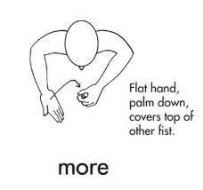 More important information about me:
E.g.
I am lots of fun, I am cheeky and have a great sense of humour. I am hypervigilant and hyperalert which can cause high anxiety and results in me getting anxious and upset easily. This can happen when other children come near me especially if they are noisy and, in these situations, I may want to hide when I feel uncomfortable.

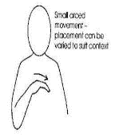 I live with:

Sometimes my… help to look after me…and where:
(e.g., childminder/family member.)

Other people who help me are (family/professionals):

Name | Title | Contact no

Objects/activities/strategies which have helped me in the past:
(Note what the strategies are and when, in the day, they are used)

E.g.
- Consistency in approaches from adults who support me.
- Transition box with special item/songs to choose.
- My own quiet workstation.
- Consistent Key Person.
- Clear boundaries from the start and clear expectations of me in the setting.
- Sensory breaks.
- Planned motivators to help transitions.
- Bucket Time.
-People who are fun/funny and motivating.

Supportive equipment:
E.g.
- I wear nappies.
- I have a walking frame.
- I have hearing aids.
- I wear glasses.

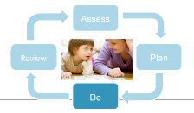 The Graduated Approach (accompanying information)

Assess:

Individual Assessment of Early Learning and Development (IAELD)
Early Years Developmental Journal (EYDJ)
WellComm
ABCCD forms
Anxiety Mapping
Roots and Fruits
Autism Questionnaire (requested by paediatrician)
Public Health Nurse (Health Visitor) 2 Year Development Check
2 Year Development Check completed by the setting.
VSEND
HfL Transition Level of Need Tool
Other (please state)

Comments: E.g., Attached with this document/ to be sent during transition/ sent with parents (only send relevant and up to date information)

Plan:

Individual Education Plan
Individual Risk Management/ Behaviour Support/ Nurture Plans
Education, Health, and Care Plan
Other (please state)

Comments: E.g., Attached with this document/ to be sent during transition/ sent with parents (only send relevant and up to date information)

Do:

Observations
Other (please state)

Comments: E.g., Attached with this document/ to be sent during transition/ sent with parents (only send relevant and up to date information)

Review:

Review documents included.
EHCP Annual Review (6 monthly review for Early Years children)
Other (please state)

Comments: E.g., Attached with this document/ to be sent during transition/ sent with parents (only send relevant and up to date information)

Have you accessed any funding?

Early Years Inclusion Funding, date of application ___________________
Disability Access Fund, date of application ____________________
Targeted Need Funding, level 1 or 2 (please circle), date of application ______________
Local High Needs Funding, date of application __________________
High Needs Funding (linked to EHCP)

Other reports or further information enclosed (or to be sent during transition/ sent with parents):

Speech and language therapy
Occupational therapy
Physiotherapy
Paediatrician
Audiology
Ophthalmology
Specialist Advisory Teacher
Educational Psychology
Public Health Nurse information (Health Visitor/ Community Nursery Nurse/ Special Needs Health Visitor)
Have you started the EHCP process? Where are you up to in the process? ______________________________________________________________________________

Other (please state) ___________________________________________________________

Any other useful and relevant information you would like to add? (Have referrals been made but the child is still on a waiting list? Have the parents attended courses such as ‘Early Talk’ or ‘More Than Words’?)
____________________________________________________________________________________________________________________________________________________________

Any other information or special things you know about me which would help my transition?
(You may want to include ‘what if?’ situations. You could gather this information using the ‘Good Day/Bad Day’ person centred plan in the SENCo Resource Pack):

What if…
E.g.
- What if I come to nursery with my coat/ bag on and I don’t want to take it off?
- What if I am bought to nursery by daddy instead of mummy and this is outside of my normal routine?
- What if I arrive to nursery late and I am struggling to transition?
- What happens if I am unwell? (How do I react)?

Special things you know about me:
- At the moment, I only like to wear wellie boots, I will wear them all year round.
- I don’t like new clothes, I find them itchy.
- When I come into nursery, I like to be by myself and explore, after 5 mins an adult can join me.
- I don’t know yet if I am hot/cold/wet/dirty/hungry/thirsty/poorly, an adult will need to help me to identify my needs. Visual cues understood by the adult are…


I hope this information will help you to get to know me better and support my transition.

